IFMA-NY Tech Valley invites all our members, guests & the curious to join us October 2, 2014 for ‘Nosh, Laugh & Roar!

‘Nosh at Aperitivo Bistro from 6-7:45 PM in the Tuscan Room
Exquisite hor d’oeuvres, salads, specialty pizza + cash bar

Laugh & Roar!
Then @ 8PM, follow us next door to PROCTORS THEATER
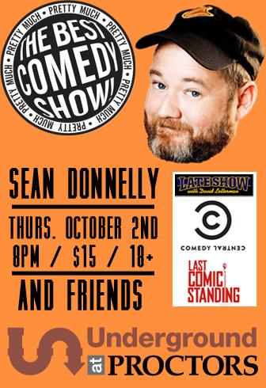
‘Nosh, Laugh + Roar! is free to our chapter members + significant other
Non-members, guests + the curious- $25 cash at event
Please contact Oleh Turczak at turczo@rpi.edu 518-276-4244
by 9/26 to reserve your seats!
http://www.proctors.org/visiting/parking
http://aperitivobistro.com/about-us#!directions

